Chapter 8, Problem 50.

For the circuit in Fig. 8.97, find i(t) for t > 0.

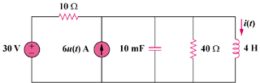

Figure 8.97
For Prob. 8.50.

